Norville Metts
1840 – April 13, 1847

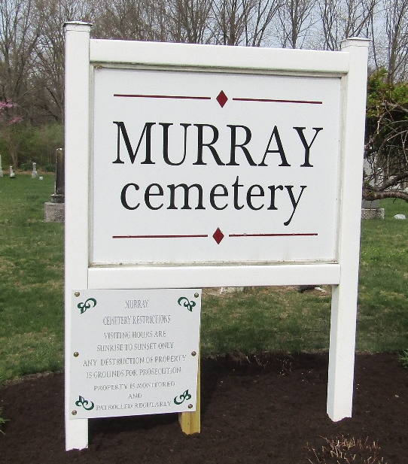

Norville/Harvel w Metts from tree Zuber/Linder Family Tree
Birth 1840 Wells, Indiana, USA
Death 13 Apr 1847
Father James Wilson Metts (1804-1874)
Mother Miranda Sutton (1807-1868)

