Miranda (Sutton) Metts
1807 – January 29, 1868

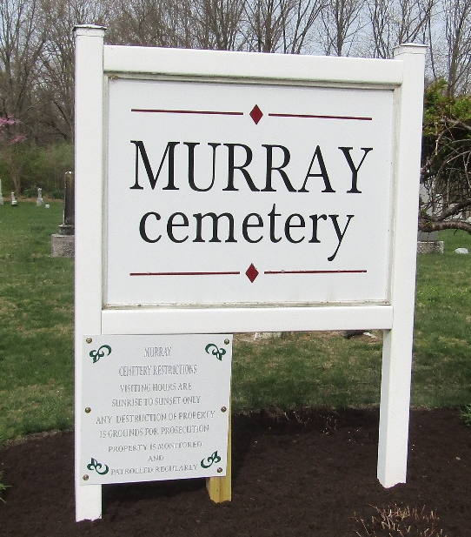

Miranda Metts Sutton from tree Filer-Woods Family
Birth 1807 Licking, Licking, Ohio, USA
Marriage 23 Sep 1827 Licking, Licking, Ohio, USA
Residence 1860 Wells, Indiana, USA
Death 29 Jan 1868 Wells, Indiana, USA
Father Elijah Sutton (1781-1845)
Mother Diana Bowles (1790-1895)
Spouse James William / Wilson Metts (1805-1874)

