Pauline Mentzer
April 5, 1904 – February 23, 1905

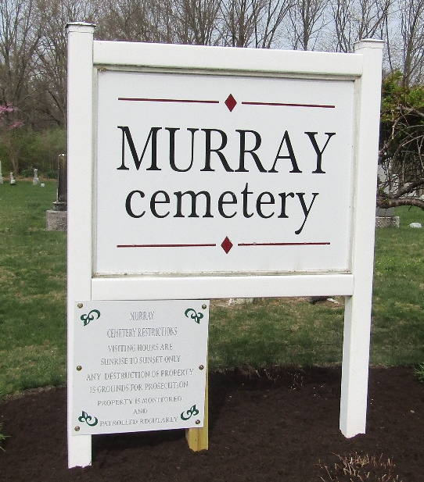

Pauline Mentzer
Indiana, U.S., Death Certificates, 1899-2017
Name Pauline Mentzer
Gender Female
Race White
Marital Status Single
Age 10 months, 18 days
Birth Date 5 Apr 1904
Birth Place Indiana
Death Date 23 Feb 1905
Death Place Bluffton, Wells, Indiana, USA
Death Registration Date 1905
Father Nathan Mentzer
Mother Rosetta Plummer
Informant Family; Bluffton, Indiana
Burial February 24, 1905; Murray Cemetery

