Willard Dixon McMillion
August 21, 1876 – July 24, 1941

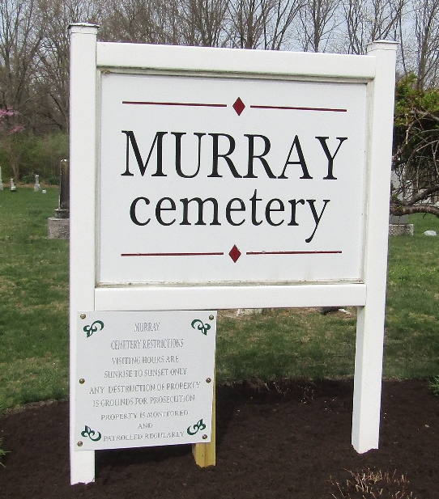

Williard Dixon Mc Millon
Indiana, U.S., Death Certificates, 1899-2017
Name Willard Dixon McMillon
Gender Male
Race White
Marital Status Married
Age 64
Birth Date 21 Aug 1876
Birth Place Renick W Virginia
Death Date 24 Jul 1941
Death Place Rural, Wells, Indiana, USA
Death Registration Date 1941
Father A C McMillon
Mother Signoria Walkup
Spouse Rebecca Shafer
Informant Oscar McMillon; Murray, Indiana
Burial July 27, 1941; Murray Cemetery; Wells County, Indiana

