Signora Lillie (Walkup) McMillion
July 1, 1856 – October 12, 1946

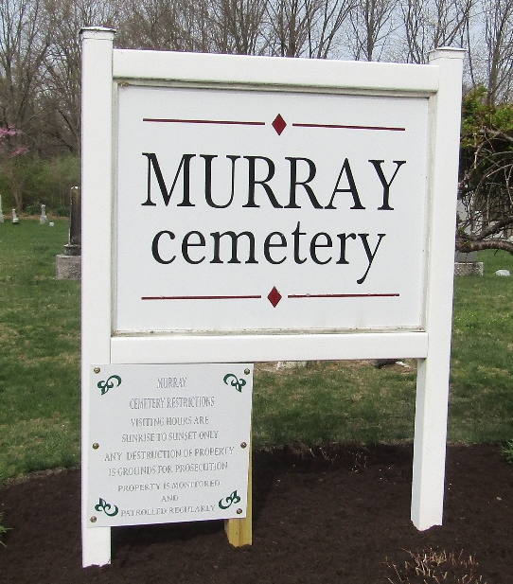

MRS. A. C. M’MILLONN ANSWERS SUMMONS

Mrs. Signora Janet L. McMillon, 90, widow of Andrew McMillon, died at 9:30 p.m. Saturday at her home at Murray, of a heart ailment. She had been failing in health for one year.
The decedent was a native of West Virginia, where she was born July 1, 1856, a daughter of James and Mary Hardway Walkup. Her marriage took place Sept. 24, 1874, and her husband’s death occurred March 24, 1935.
Mrs. McMillon, who had resided in Wells County 34 years, was a member of the Baptist Church.
Survivors include two sons, Oscar McMillon, of Murray, and Albert McMillon of West Virgina; 18 grandchildren and eight great-grandchildren.
The body was removed to the Thoma Funeral Home and will remain there until time of the funeral services to be held at 2 p.m. Tuesday at the Christian Church at Murray. Burial will be in the Murray Cemetery. Rev. Homer Studabaker will conduct the services.

Bluffton News Banner, Wells County, Indiana
October 14, 1946

**
Siguard Lillie Welkup McMillen
Indiana, U.S., Death Certificates, 1899-2017
Name Signora Lillie Walkup McMillion
Maiden Name [Walkup]
Gender Female
Race White
Marital Status Widowed
Age 90
Birth Date 1 Jul 1856
Birth Place W Virginia
Death Date 12 Oct 1946
Death Place Rural, Wells, Indiana, USA
Death Registration Date 1946
Father James Walkup
Mother Mary B Hardway
Spouse Andrew McMillion
Informant Oscar McMillion; Murray, Indiana
Burial October 15, 1946; Murray, Indiana

