Oscar McMillion
August 10, 1886 – December 12, 1959

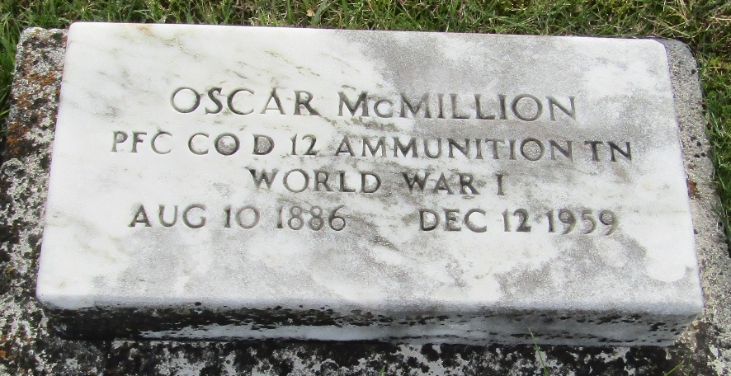

Oscar McMillion
Indiana, U.S., Death Certificates, 1899-2017
Name Oscar McMillion
Gender Male
Race White
Marital Status Never Married (Single)
Veteran World War I
Age 73
Birth Date abt 1886
Birth Place West Virginia
Death Date 12 Dec 1959
Death Place Bluffton, Wells, Indiana, USA
Death Registration Date 1959
Father Andrew McMillion
Mother Sarah
Informant Hie J. Johnlon; friend; Murray, Indiana
Burial December 14, 1959; Murray Cemetery; Murray, Indiana

