Ira Callison McMillion
March 21, 1890 – November 18, 1929

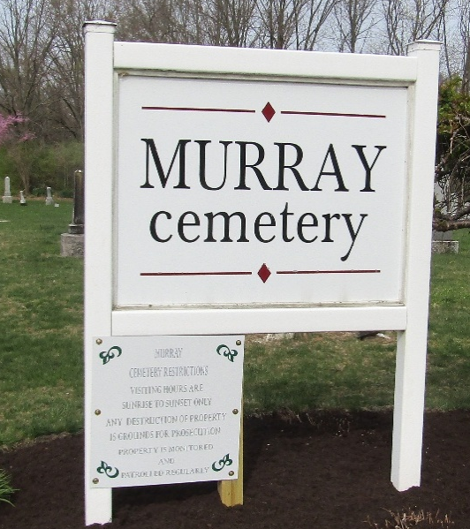

IRA M’MILLION DIES AT HOSPITAL
PASSES AWAY MONDAY EVENING AT THE IIRENE BYRON HOSPITAL

Ira McMillion 39, son of A. C. McMillion, died at Irene Byron sanitarium near Fort Wayne, Monday evening. He had been ill with tuberculosis for some time.
His home is in Murray.
He is survived by the wife and 5 children. The children are Chester, Mildred, Melvin, Elsie, and Ina. Two brothers also survive. They are Oscar McMillion of Murray, and Willis McMillion.
Funeral Services will be held at the Murray Christian Church Thursday afternoon, and burial will be in the Murray Cemetery.

Bluffton News Banner, Wells County, Indiana
November 19, 1929

**
Indiana, U.S., Death Certificates, 1899-2017
Name Ira Collison McMillion
Gender Male
Race White
Marital Status Married
Age 39
Birth Date 21 Mar 1890
Birth Place Renick, W. Virginia
Death Date 18 Nov 1929
Death Place Fort Wayne, Allen, Indiana, USA
Death Registration Date 1929
Parents Not listed
Informant Not listed
Burial November 21, 1929; Murray, Indiana

**
Ira Callison McMillion from tree Ludwick Family Tree
Birth 21 Mar 1890 Renick, Greenbrier, West Virginia, USA
Marriage 27 Nov 1913 Greenbrier, West Virginia, USA
Residence 1920 Falling Spring, Greenbrier, West Virginia, USA
Death 18 Nov 1929 Fort Wayne, Allen, Indiana, USA
Father Andrew Callison "AC" McMillion (1852-1935)
Mother Signora "Nora" J L Walkup (1856-1930)
Spouse Nora Irene Nelson (1895-1980)

