Andrew C. McMillion
March 24, 1852 – March 24, 1935

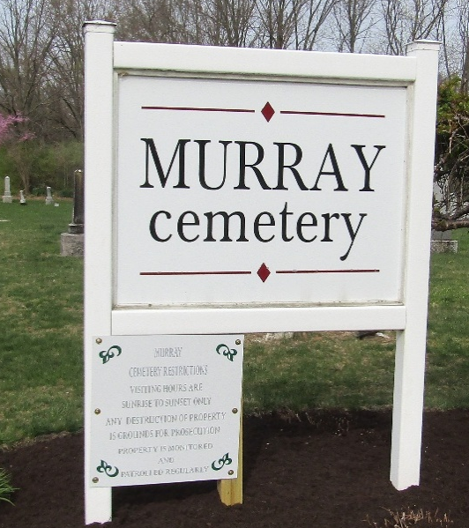

Andrew C McMillion
Indiana, U.S., Death Certificates, 1899-2017
Name Andrew C McMillion
Gender Male
Race White
Marital Status Married
Age 83
Birth Date 24 Mar 1852
Birth Place West VA
Death Date 24 Mar 1935
Death Place Murray, Wells, Indiana, USA
Death Registration Date 1935
Father Andrew McMillion
Mother Jane McClung
Spouse Signora Walkup
Informant Oscar McMillion; Murray, Indiana
Burial March 27, 1935; Murray Cemetery

