Mary Lawson (Ruth) McCrea
April 18, 1834 – December 22, 1881

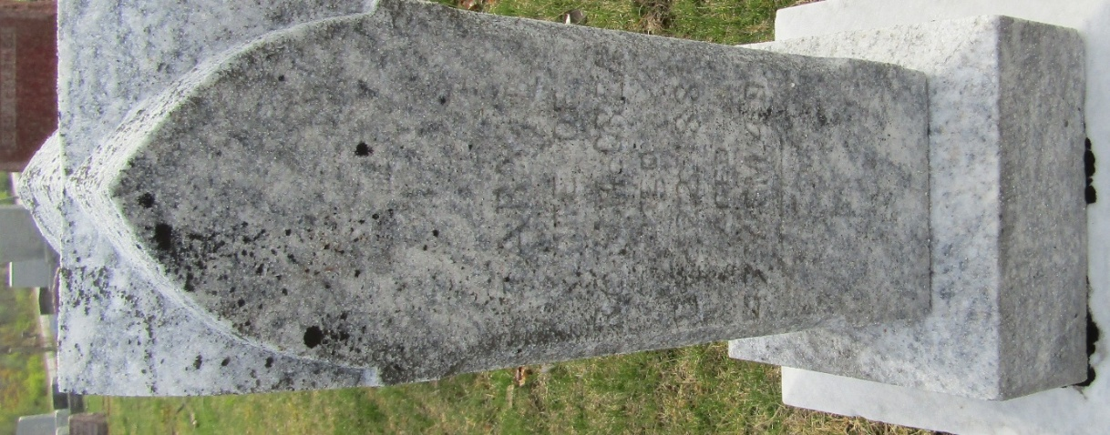

Mary Lawson McCrea from tree Brown Family Tree
Birth 18 Apr 1834 Washington, Pennsylvania, USA
Marriage 3 Jul 1856 Guernsey, Ohio, USA
Residence 1880 Wells, Indiana, USA
Death 22 Dec 1881 Wells, Indiana, USA
Father Samuel C Ruth (1807-1887)
Mother Margaret Porter (1806-1879)
Spouse Jonas McCrea (Born 1819)

