Samuel H. McClellan
1880 – January 10, 1864

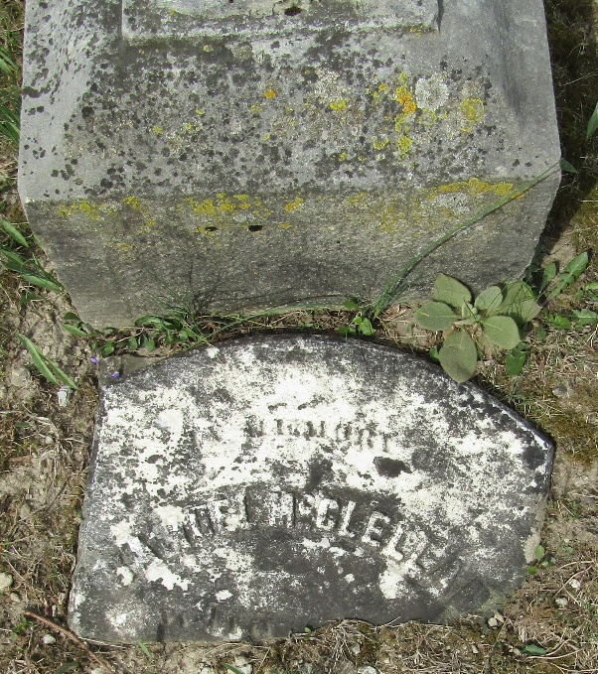

Samuel H McClellan from tree McClellan Family Tree
Birth 1800
Death 10 Jan 1864
Spouse Rosa McClellan

