Loyd Brooks McCarty
August 27, 1910 – December 7, 1978

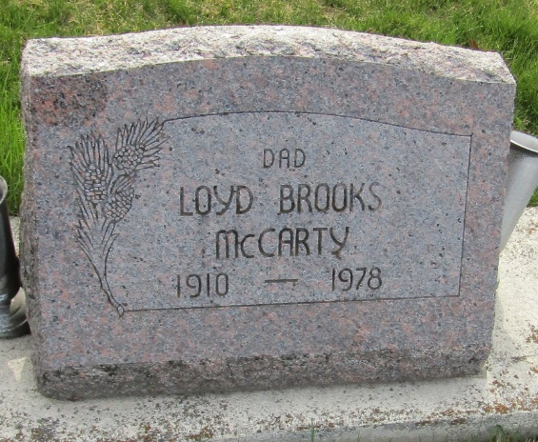

Brooks McCarty Rites Saturday

Funeral services for veteran accountant and former treasurer of Wells County, L. Brooks McCarty, 68, who was found dead in his apartment at 110 North Johnson Street at 9 a.m. Thursday, will be at 3 p.m. Saturday at Goodwin Memorial Chapel with Dr. Phillip Hazelton officiating. Burial will be in the Murray Cemetery.
Calling is after 1 p.m. today at the funeral home with preferred form of remembrance a contribution to the Wells Community Hospital Building Fund.
Ill the past few weeks due to a respiratory ailment, it is believed Mr. McCarty died of an apparent heart condition about 1 a.m. Thursday as he sat in a chair in the apartment.
In addition to other activities listed in Thursday’s account, Mr. McCarty was a member of the Elks Lodge, a former member of the Bluffton Kiwanis Club and had attended the First Presbyterian Church.

Bluffton News Banner, Wells County, Indiana,
December 8, 1978

**
L Brooks McCarey
Indiana, U.S., Death Certificates, 1899-2017
Name L Brooks McCarey
Gender Male
Race White
Marital Status Divorced
Age 68
Birth Date 27 Aug 1910
Birth Place Indiana
Death Date 7 Dec 1978
Death Place Bluffton, Wells, Indiana, USA
Death Registration Date 1978
Father James McCarty
Mother Rosa V Lyby
Informant Mrs. Betty Ehrsam; Bluffton, Indiana
Burial December 9, 1978; Murray Cemetery; Bluffton, Indiana

