James O. McCarty
March 9, 1870 – August 29, 1947

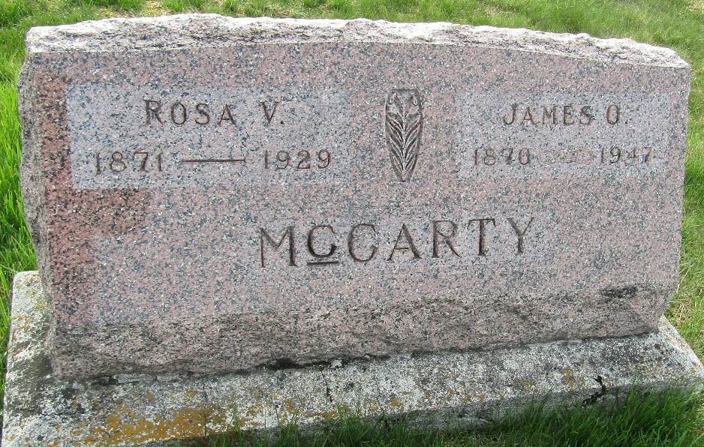

James O McCarty
Indiana, U.S., Death Certificates, 1899-2017
Name James O McCarty
Gender Male
Race White
Marital Status Widowed
Age 77
Birth Date 9 Mar 1870
Birth Place Clinton County, Indiana
Death Date 29 Aug 1947
Death Place Liberty Center, Wells, Indiana, USA
Death Registration Date 1947
Father Nathaniel McCarty
Mother Editha Pierce
Spouse Rosa V
Informant Brooks McCarty; Bluffton, Indiana
Burial September 1, 1947; Murray Cemetery; Wells County, Indiana

