Virginia (Fowler) McCain-Gleim
October 3, 1848 – July 8, 1917

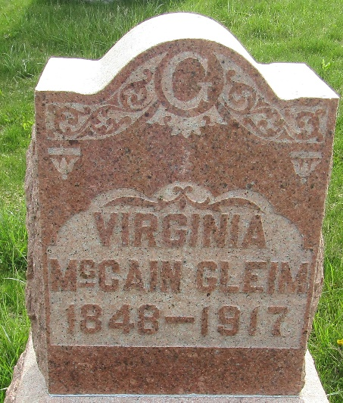

Virginia Gline
in the Indiana, U.S., Death Certificates, 1899-2017
Name Virginia Glime
Gender Female
Race White
Marital Status Married
Age 69
Birth Date October 3, 1848
Death Date 8 Jul 1917
Death Place Lancaster, Wells, Indiana, USA
Death Registration Date 1917
Spouse Glime
Parents Blurred out
Informant Blurred out
Burial July 12, 1917; Murray Cemetery

**
Indiana, U.S., Marriages, 1810-2001
Name Virginia Mccain
[Virginia Fowler]
Gender Female; Race White
Age 64
Birth Date 3 Oct 1848
Birth Place Pennsylvania
Marriage Date 22 Oct 1912
Marriage Place Indiana, United States
Residence Place Farmland, Indiana
Father William Fowler
Mother Sarah Rogers
Spouse George Gleim
Officiator Thomas A Helms
Page 234

