Jane Lockhart (McNary) McBride
October 23, 1828 – May 23, 1903

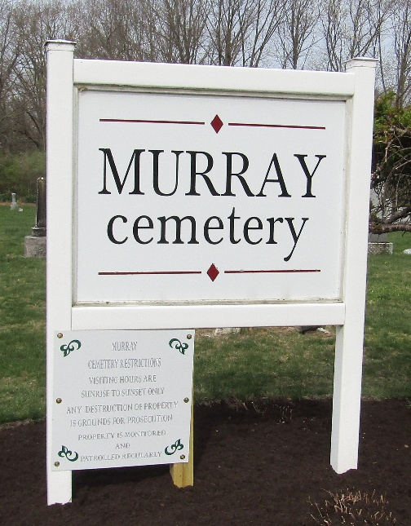

Jane Lockett Mc Bride
Indiana, U.S., Death Certificates, 1899-2017
Name Jane Lockert Mc Bride
Race White
Marital Status Widow
Age 74
Birth Date 23 Oct 1828
Birth Place Washington County, Pennsylvania
Death Date 23 May 1903
Death Place Bluffton, Wells, Indiana, USA
Death Registration Date 1903
Father Mc Nary
Mother Fulton
Spouse J L Mc Bride
Informant Maggie Greek; Bluffton, Indiana
Burial May 24, 1903; Murray Cemetery

