Samuel J. McAfee
December 29, 1839 – February 17, 1918

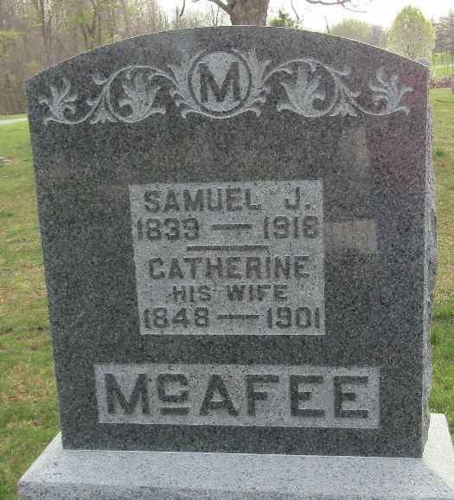

Samuel J. McAfee Died of Blood Poison
Prominent Elderly Farmer Died Sunday Night After Brief Illness.

Samuel J. McAfee, seventy-nine, a prominent Lancaster township
pioneer, died at his home just south of Kingsland, at 10:30 Sunday
night, after a short illness with blood poisoning in his right arm,
which developed from a slight cut received while butchering on last
Wednesday. He passed away a short time after submitting to an operation for the opening of the infected member, which was resorted to as the only means of saving his life. It is probable that the illness would not have been fatal in a younger man. Mr. McAfee cut the third finger of his right hand while helping to butcher, but gave the wound no attention as it was scarcely more than a scratch. His hand had been crippled several years ago when he lost two joints of the second finger when the digit caught in a heavy pulley.
The blood poison began to develop on Friday and he became worse rapidly until on Sunday Mr. McAfee's arm was in a terribly swollen condition. A consultation was held over him on Sunday afternoon and the operation for opening the infected area was decided on. The poison had gained too great a hold on his system, however, and the operation proved of no avail.
Mr. McAfee was born in Pittsburg on December 29, 1839, the son of
James and Rachael (Dinsmore) McAfee, natives of County Antrim, Ireland and of Scotch covenanter descent. They moved to Wayne County, OH a short time after the birth of the decedent. His mother passed away in 1844 and in 1853 he came to Wells County, IN with his father and settled in Lancaster township, near where his present home is located.
Mr. McAfee was married on September 28, 1865 to Miss Rachel Nelson, a native of Wells County, IN and a daughter of James Nelson and wife, of Lancaster township, who were pioneer settlers of the county. She was a sister of the late Solomon Nelson, of this city. Mrs. McAfee died on November 9, 1871 leaving two daughters. One daughter, Atta A., the widow of William Wasson, of Lancaster town-ship, survives her father and the other, Ella, passed away in young womanhood.
Mr. McAfee was married a second time, September 29, 1873 to Miss Catherine Maddux, who was the daughter of Jacob Maddux and wife, of Lancaster township. Two sons were born to this union, Ernest W. and Marion J. McAfee, both of whom survive. The decedent made his home with the last named son, who lived on his father's farm, just south of Kingsland. Mrs. McAfee has been dead for a number of years.
Besides the daughter and sons Mr. McAfee is survived by five grandchildren and one great-grandchild, the baby daughter of Mr. and Mrs. Lantz Wasson, of Lancaster township. He also leaves a brother and sister, namely: William J. McAfee of this city, who only recently returned from a winter visit to Georgia, and Miss Maria McAfee, who keeps house for her brother-in-law, James Earl, residing north of Murray.

Unknown source

**
DIED FROM ACCIDENT

The death of Samuel J. McAfee, an aged pioneer of Lancaster Township, occurred at his home four miles south of Ossian at 10:30 Sunday night. The cause of his death was blood poisoning due to a cut on the third finger of his right hand when he was assisting in the butchering on the Will Snyder farm on Wednesday of last week. The wound was given no attention, as it was considered of no consequence by Mr. McAfee, but when the finger began to pain him, he wrapped the injured member up. On Friday the hand began to swell, and on Sunday afternoon an operation was performed, but the poison had gained too great a hold upon the aged man’s system, and he quietly passed away.
The funeral services occurred Tuesday afternoon at the farm home just south of Kingsland, Rev. Francis K. Baker officiating. Interment was made in the Murray Cemetery. The following obituary was read by the pastor: Samuel J. McAfee, one of the well-known and highly esteemed citizens of Wells County, passed away Sunday evening, February 17th, 1918 after a brief illness caused by blood poisoning, aged 78 years, one month and sixteen days.
He was born in Pittsburg, Pa., December 29, 1839, and moved with his father’s family to Wells County, Indiana in 1853, at the age of fourteen years, where he spent the remainder of his life. He was thus one of the early pioneers of the county, which he helped to develop from a swampy wilderness to the present improved rich agricultural district.
Mr. McAfee became, in early life, an active member of the Murray Presbyterian Church, and later took a leading part in building and organizing a Presbyterian Church at Kingsland. He was always faithful in attending the Sabbath School and other church services, and was always a willing and efficient helper in all church work. When the church at Kingsland was discontinued, he transferred his membership to the Ossian Presbyterian Church, of which he was a member at the time of his death.
In his home life he was a hard worker, an obliging neighbor, and a kind and loving husband and father. He was married to Rachel Nelson, on September 28, 1865, the wife passing away November 9, 1871, leaving two daughters, Mrs. Etta Wasson, living in Lancaster Township, and Florence E., now deceased. On September 29, 1873 he was united in marriage to Catherine Maddux, who died in May, 1901. To this union were born two sons, Ernest W., and Jacob M., living on the home place. In addition to these, one brother, William J. McAfee of Bluffton, and one sister, Hannah M. McAfee, of Lancaster Township, survive, also five grandchildren and one great-grandchild, and a host of friends to mourn their loss.

Ossian Journal, Wells County, Indiana
February 22, 1918

**
Indiana, U.S., Death Certificates, 1899-2017
Name Samuel J. McAfee
Gender Male
Race White
Marital Status Widowed
Age 78
Birth Date 29 Dec 1839
Birth Place Pennsylvania
Death Date 17 Feb 1918
Death Place Lancaster, Wells, Indiana, USA
Father James McAfee
Mother Rachel Dinsmore
Spouse Catharine
Informant Jacob McAfee; Ossian, Indiana
Burial February 19, 1918; Murray Cemetery

