Rachel (Nelson) McAfee
February 10, 1848 – November 9, 1871

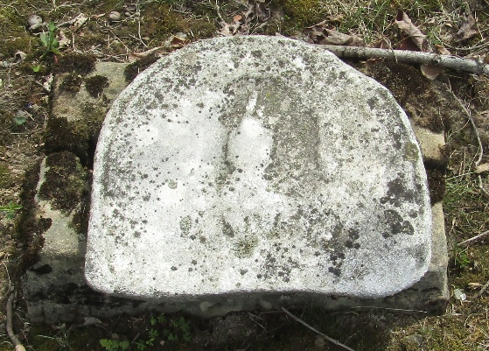

Rachel Nelson from tree anderson-johnston Family Tree
Birth 10 Feb 1848 Adams, Indiana, USA
Marriage 28 Sep 1865 Wells
Death 9 Nov 1871
Father James Nelson (1813-1886)
Mother Sarah J. Beals (1815-1885)
Spouse Samuel James McAfee (1829-1918)

