James McAfee
January 5, 1809 – July 12, 1862

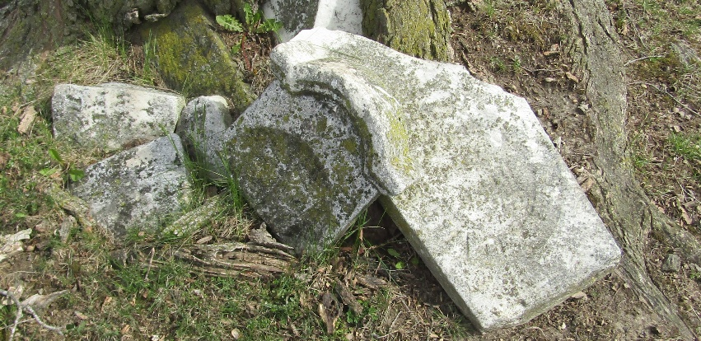

James McAfee from tree Hall/ Slagle Family Tree
Birth 5 Jan 1809 Bushmills, Antrim, Northern Ireland
Marriage 12 Nov 1846 Wayne, Monroe, Ohio, USA
Residence 1860 Wells, Indiana, USA
Death 12 Jul 1862 Wells, Indiana, USA
Father William McAfee (1777-1858)
Mother Margaret Martha Taggert (1780-1864)
Spouse Elizabeth Jane Cherry (1820-1896)

