Florence Ellen McAfee
1871 – September 25, 1890

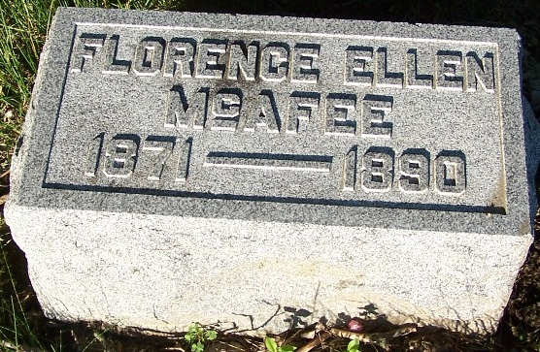

Miss Ella McAfee died at the home of her parents near Kingsland,
Thursday evening Sept. 25th, 1890, aged 19 years and 14 days.
Her death is a cause of sorrow to the entire neighborhood, as she
was universally esteemed and loved. She was an earnest christian, a
faithful member of the Kingsland church and Sunday school, where she was teacher of the infant class; an affectionate, obedient daughter; a loving sister and a kind and cheerful companion to all her young
friends. At church, at home, at school and in society her influence
was always exerted for good and her example worthy to be followed by others. Shortly before her death she bid all her friends farewell and
requested them to meet her in the better world.
A large number attended the funeral, which was held at the house, Friday. A beautiful and appropriate sermon was preached by Rev. Lawson, from the text "Her Sun hath set while it is yet day." Her remains were laid to rest in the Murray cemetery. While all will miss her happy cheerful presence from among us, yet there is comfort in the thought that, although her sun has ceased to shine here, it has set to rise in a better world of peace and joy.

Unknown source

**
Florence Ellen McAfee from tree Charles E. Griffin Family Tree

Birth 1871 Wells, Indiana, USA
Residence 1880 Wells, Indiana, USA
Death 1890
Father Samuel James McAfee (1839-1918)
Mother Rachel Nelson (1849-1871)

