Catherine (Maddux) McAfee
December 28, 1848 – May 23, 1901

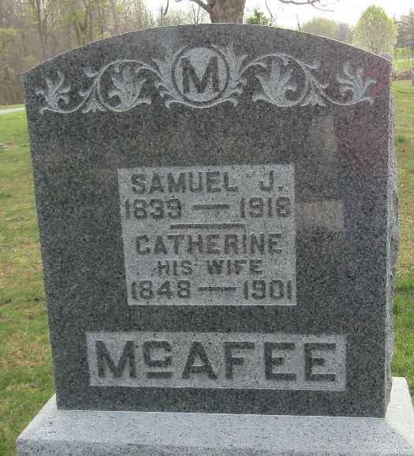

LAID DOWN TO REST
Mrs. Samuel J. McAfee, of Lancaster Township, Dies Suddenly while Her Husband is Absent

Mrs. Samuel J. McAfee, residing five miles and a half north of the city, died very suddenly this morning at half past nine o’clock. She had been up and around the house and had eaten a hearty breakfast. Although she had not been well for some time, she did not consider herself, nor did her family, to be in a dangerous condition. She lay down to rest, and in a few moments was dead, in which condition she was found by Mrs. Charles Ellison, a neighbor, who was at the McAfee home. Mr. McAffee had gone to Ossian earlier in the morning and was away at the time. The farm bell was rung, and neighbors were summoned to the house. Mrs. McAfee attributed her illness to an attack of measles, with which she suffered four or five years ago, and she has not been strong since. Tumor of the brain is supposed to have been the immediate cause.
Mrs. McAfee was one of the most estimable ladies of Lancaster Township. She was a daughter of Jacob Maddux, who settled in Lancaster Township in 1838, and she was born on the home farm, December 28, 1848.
Mr. and Mrs. McAfee were married September 29, 1873. She was a second wife, his first wife being a sister of Sol Nelson, of this city. She leaves two sons, Ernest W. and Jacob M., both grown, and a stepdaughter, Mrs. Will Wasson. Mrs. Richard Bush was a sister of the deceased.
The funeral will be held at the house at two o’clock tomorrow afternoon with burial at Murray Cemetery.

Evening News, Wells County, Indiana
May 23, 1901

**
Catharine McAfee
Indiana, U.S., Death Certificates, 1899-2017
Name Catharine McAfee
[Catharine Maddux]
Gender Female
Race White
Marital Status Married
Age 50 years, 4 months, 25 days
Birth Date abt 1851; Birth Place Wells County, Indiana
Death Date 23 May 1901; Death Place Lancaster, Wells, Indiana, USA
Death Registration Date 1901
Father Jacob Maddux
Mother Anna M Evans
Informant Samuel McAfee
Burial May ?, 1901; Murry Cemetery
**
Catherine McAfee (born Maddux) from tree 1 Young (Ferry)-Lamb

(Perry) : Powell (Tarver)-Edwards (Stephens) family tree
Birth 28 Dec 1848 Wells, Indiana, USA
Marriage 1872 Wells, Indiana, USA
Residence 1900 Wells, Indiana, USA
Death 23 May 1901 Wells, Indiana, USA
Father Jacob Maddux (1818-1884)
Mother Mary Anna “Ann” Maddux (born Evans) (1820-1884)
Spouse Samuel James McAfee (1839-1918)

