Sarah (Rogers) Kirkpatrick-Marquis
September 29, 1795 – September 4, 1849

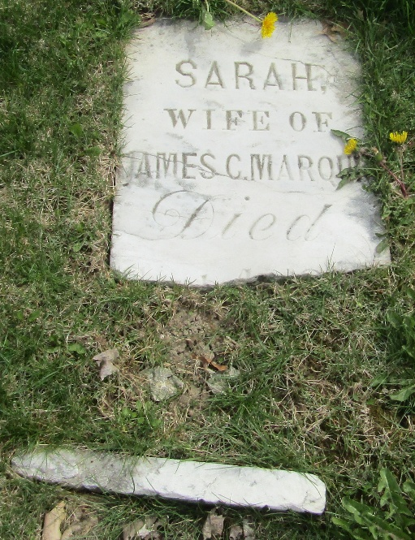

Sarah Rogers from tree max99
Birth 29 Sep 1795 Pennsylvania, USA
Marriage 4 Mar 1820 Vanderburgh, Indiana, USA
Residence 1830 Posey, Indiana, USA
Death 4 Sep 1849 Wells, Indiana, USA
Father Randolph Rogers (1776-1822)
Mother Milley Peary (1780-1850)
Spouse James Marquis (1785-1846)

