James Crawford Marquis
May 29, 1785 – August 17, 1846

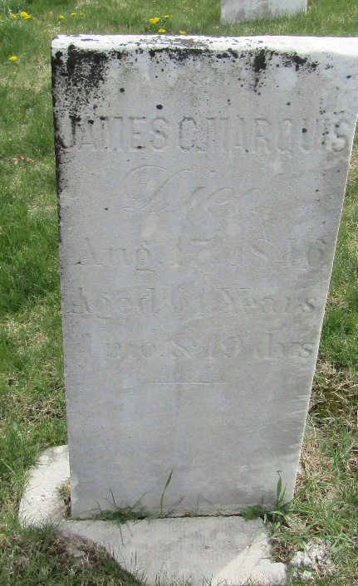

James Crawford Marquis from tree Marquis Jahn Family_2023
Birth 29 May 1785 Cross Creek, Washington, Pennsylvania, USA
Marriage 20 Jul 1815
Residence 1840 Jamestown, Boone, Indiana, USA
Death 17 Aug 1846 Wells, Indiana, USA
Father Robert Marquis (1760-1819)
Mother Hannah Crawford (1760-1820)
Spouse Sarah Kirkpatrick (1795-1849)

