Jacob Maddux
September 18, 1818 – February 9, 1884

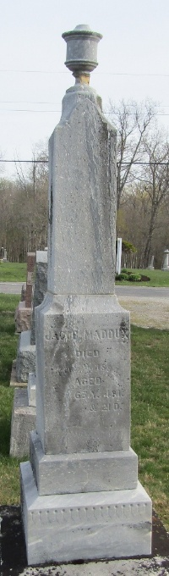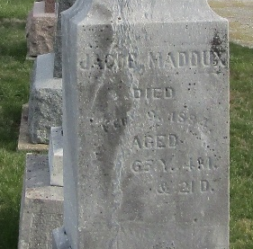

Died at his home five miles north of Bluffton, Ind., Jacob Maddux. Father Maddux was born in Miami County, Ohio, Sept. 18th, 1818 and died Feb. 9th, 1884, aged 65 yrs, 4 m. and 21 days.
With his father and one brother, he moved to Wells County, Ind., in the spring of 1839. That summer he married Miss Ann Evans, who survives him. In 1840 he settled on the farm where he lived until the day of his death. This country was then an almost unbroken wilderness.
Father Maddux was an exceptionally good man, a kind neighbor, a loving father and true husband. One by one the pioneers of our country are leaving us.
The funeral services were held at his late home, conducted by Rev. J. H. Reider. The large attendance, notwithstanding the stormy weather, indicated very truly the high esteem in which he was held. He leaves his aged widow and four daughters, with a large circle of warm friends to mourn their loss.
Unknown source
**
Jacob Maddux from tree Johnson
Birth 18 Sep 1818 Miami, Ohio, USA
Marriage 28 Sep 1842 Miami, Clermont, Ohio, USA
Residence 1880 Wells, Indiana, USA
Death 9 Feb 1884 Bluffton, Wells, Indiana, USA
Father John T. Maddox (1788-1864)
Mother Catherine Arnold Maddux (1791-1872)
Spouse Mary Anna Evans Maddux (1820-1884)

