Ida Alice (Hege) Maddux
December 29, 1874 – June 8, 1924

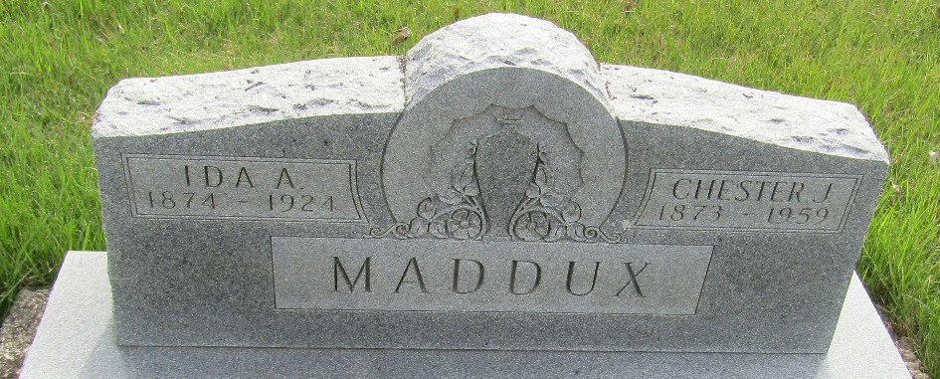

Mrs. Chester Maddux Passed Away Sunday
Mrs. Ida Alice Maddux, 49, wife of Chester Maddux, living five miles north and one-half mile west of Bluffton, died at 11:15 a.m. Sunday at the Lutheran hospital, Fort Wayne. Death was due to pneumonia. She was taken to the hospital on May 27th, and was thought to be getting along nicely, until suddenly stricken by a severe attack Sunday forenoon. She passed away before members of the family could reach the hospital.
The husband, two sons, Dwight and Charlie, and a daughter, Bildred [sic-Mildred], survive.

Bluffton Evening News, Wells County, Indiana
Saturday, June 14, 1924 (sic)
**
Indiana, U.S., Death Certificates, 1899-2017
Name Mrs Ida Alice Maddux
[Mrs Ida Alice Hege]
Gender Female
Race White
Marital Status Married
Age 49
Birth Date 29 Dec 1874
Birth Place Huntington County, Indiana
Death Date 15 Jun 1924
Death Place Fort Wayne, Allen, Indiana, USA
Death Registration Date 1924
Father Amos Hege
Mother Mary Patton
Spouse Chester J.H. Maddux
Informant Family; Bluffton, Indiana
Burial June 17, 1924; Bluffton cemetery

