Chester J. H. Maddux
July 25, 1873 – September 3, 1959

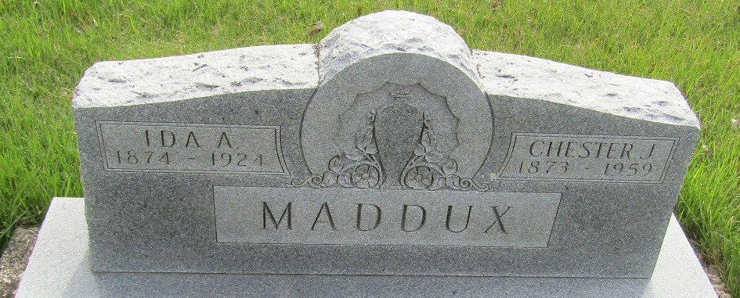

Chester Maddux Dies at Age 86
Chester J. H. Maddux, 86, of Yucaipa, Calif., died at 11:25 p.m. Thursday at the Wells County Hospital, where he had been a patient nine weeks. Death was attributed to a heart condition.
Mr. Maddux was born July 25, 1873, in Lancaster Twp., to Jacob and Elizabeth Platter Maddux. His marriage to Ida Alice Hege, whose death occurred June 15, 1924, took place Aug. 11, 1894, in Bluffton.
A retired farmer, Mr. Maddux had resided in Wells County until moving to California 20 years ago.
Survivors include two sons, Dwight Maddux of Ossian Route 2 and Charles Maddux of Bluffton; a daughter, Mrs. Harold (Mildred) Lockwood of Yucaipa, Calif.; six grandchildren and six great-grandchildren. A brother, W. E. Maddux, is deceased.
The body was taken to the McBride Funeral Home, where friends may call after 7 o'clock this evening. Services will be conducted at 2 p.m. Sunday at the funeral home, with Rev. R. C. Koch officiating. Burial will be in the Murray Cemetery.

News Banner, Wells County, Indiana
Friday, September 4, 1959

