Michael D. Macon
February 29, 1943 – June 21, 2007

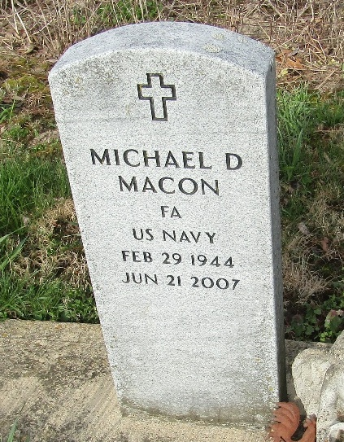

Michael D. Macon, 63, of Steinbarger Lake, Rome City, died at 11 p.m. on Thursday, June 21, 2007, at Goshen Memorial Hospital. He was a self-employed contractor, having retired in 1997.
He was born in Wells County on Feb. 29, 1943, a son of Donald I. and Margaret E. (Stewart) Macon. He was a 1962 graduate of Lancaster High School and served in the U.S. Navy from 1962-63. He played basketball for Lancaster High School, and enjoyed trapping and hunting.
He is survived by his father, of Bluffton, two daughters Lisa (Charles) Bouvette of Gulfport, Miss., Michelle (Damian) Cole of Muncie, two brothers Vaughn (Marlene) Macon of Bluffton, and Steve G. (Cathy) Macon of Badger, Minn., and two sisters Madonna S. Craig of Bluffton, and Cheri (Larry) Baumgartner of Ossian.
No visitation is planned. There will be a graveside service on Monday at 1:30 p.m. at Murray Cemetery, with Pastor Mike Gilbert officiating. American Legion Post #111 will be conducting graveside military honors.
Memorials may be made to the Marion V.A. Hospital.

Goodwin Memorial Chapel, Wells County, Indiana
June 22, 2007

