Margaret Earle (Steward) Macon
June 15, 1921 – October 4, 1986

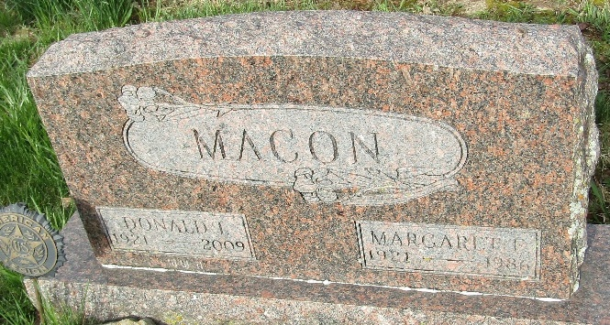

Mrs. Donald Macon, 65, Dies After Extended Illness; Rites Thursday

Ill the past 10 years due to a heart condition, Mrs. Donald (Margaret Earle) Macon, 65, of Bluffton Route 5, died at 7:30 p.m. Saturday in Hemphill Hospital in Hemphill, Texas, where the Macon’s had gone in August to spend the winter months.
Mrs. Macon, who retired in 1976 from Franklin Electric Co., where she had been employed 16 years, was a member of the Lancaster Homemakers Club and of the Circle 8 Square Dance Club.
A daughter of Otis E. and L. Stienbarger Steward, she was born June 15, 1921 in Noble County. Her marriage to Donald I. Macon, who survives, took place June 15, 1941, in Ligonier.
Surviving in addition to the husband are three sons, Steven G. Macon of Phoenix, Ariz., Vaughn E. Macon and Michael D. Macon, both of Bluffton; two daughters, Mrs. John (Mardonna) Craig of Alburquerque, N.M. and Mrs. Larry (Cherylynne) Baumgartner of Ossian, and eight grandchildren.
From 2 to 5 and 7 to 9 p.m. Wednesday, friends will be received at the Elzey-Dickey-Haggard Funeral Home in Ossian. Services there at 10:30 a.m. Thursday will be in charge of Rev. Mark Oda. Burial will be in the Murray Cemetery.
Preferred are memorials to the Indiana Diabetes Association.

Bluffton News-Banner, Wells County, Indiana,
October 6, 1986

**
Texas, U.S., Death Index, 1903-2000
Text Only

Name Margaret Earl Macon
Gender Female
Death Date 4 Oct 1986
Death Place Sabine, Texas, USA

**
U.S., Social Security Death Index, 1935-2014

Name Margaret Macon
Social Security Number xxx
Birth Date 15 Jun 1921
Issue year Before 1951
Issue State Indiana
Last Residence 46714, Bluffton, Wells, Indiana, USA
Death Date Oct 1986

**
Indiana, U.S., Marriages, 1810-2001

Name Margaret Earle Steward
Gender Female
Race White
Age 20
Event Type Marriage Registration (Marriage)
Birth Date 15 Jun 1921
Birth Place Brimfield, Noble, Indiana
Marriage Date 12 Jun 1941
Marriage Place Indiana, United States
Residence Place Fort Wayne, Indiana
Father Otis Earl Steward
Mother Vina Bell Stienbarger
Spouse Donald I Macon
Page 308
FHL Film Number 002130292

