Donald Irwin Macon
March 1, 1921 – May 1, 2009

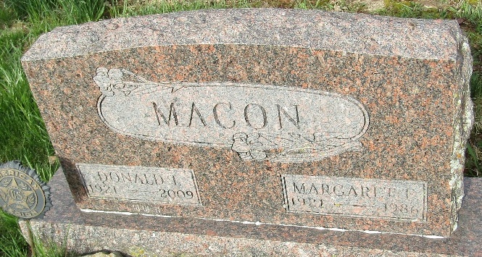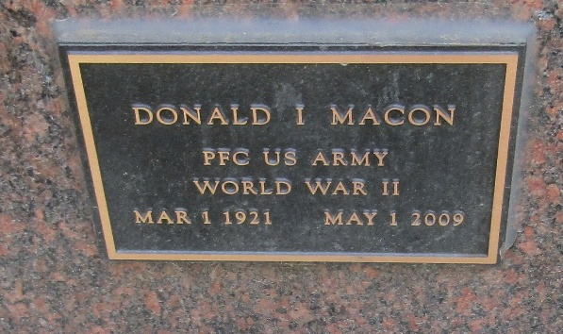

Donald I. Macon, 88

Former Bluffton resident Donald I. Macon, 88, died Friday, May 1, 2009 at 4:15 p.m. (CST) in Mesa, Ariz. Born in Trenton, Ind., on March 1, 1921 to Perry James and Helen (Jenks) Macon, he married Margaret E. Steward on June 15, 1941 in Ligonier; she died on October 4, 1986.
A 1919 graduate of Lancaster Central High School, he was a veteran of the U. S. Army during World War II. He worked for General Electric for 44 years and was a life member of the American Legion Post 111. He was an avid fisherman and enjoyed square dancing with his wife, Margaret.
Survivors include two sons, Steven G. (Cathy) Macon of Casa Grande, Ariz., and Vaughn E. (Marlene) Macon of Bluffton; two daughters, Madonna Craig of Mesa, Ariz., and Cherylynne (Larry) Baumgartner of Ossian, two sisters, Mrs. Valda Heinkle of Fort Wayne and Mrs. Delores Hendrick of Huntington, and eight grandchildren, three step-grandchildren and eight great-grandchildren.
A son, Michael D. Macon, preceded him in death.
Services will be held Thursday at 10:30 a.m. at the Goodwin Memorial Chapel in Bluffton with Pastor Mike Gilbert officiating. Calling hours there are Wednesday from 2 to 8 p.m. Burial will be in the Murray Cemetery.
The U. S. Army, in conjunction with the Grover Sheets Post 111 of the American Legion, will be in charge of the graveside services.

Bluffton News-Banner, Wells County, Indiana
Indiana, May 2, 2009

**
Indiana, U.S., Birth Certificates, 1907-1944
Name Donald Irvin Macon
Gender Male
Birth Date 1 Mar 1921
Birth Place Jackson, Blackford, Indiana, USA
Father Perry Macon; age 27
Mother Hellen Jenks; age 27; 1st child
Certificate Number 11897
Roll number 40474_356377
Volume Range 19 - 24
**
U.S., Department of Veterans Affairs BIRLS Death File, 1850-2020
Name Donald Irvin Macon
Gender Male
Birth Date 1 Mar 1921
Death Date 1 May 2009
SSN xxx
Enlistment Branch Army
Enlistment Date 24 May 1944
Discharge Date 16 Sep 1945
Page number 2

