Emeline Mabee
April 18, 1847 – March 19, 1864

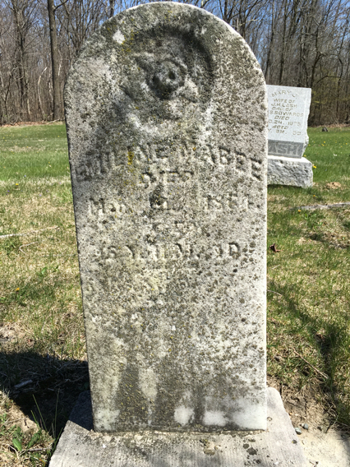
Photo by Barbara Baker Anderson

Emeline Maybee from tree Maybee Society
Birth 18 Apr 1847 Ohio, USA
Residence 1860 Wells, Indiana, USA
Death 19 Mar 1864 Wells, Indiana, USA
Father David Maybee (1818-1864)
Mother Elizabeth Lesh (1819-1894)

