Elisabeth (Lesh) Mabee
September 19, 1819 – December 16, 1894

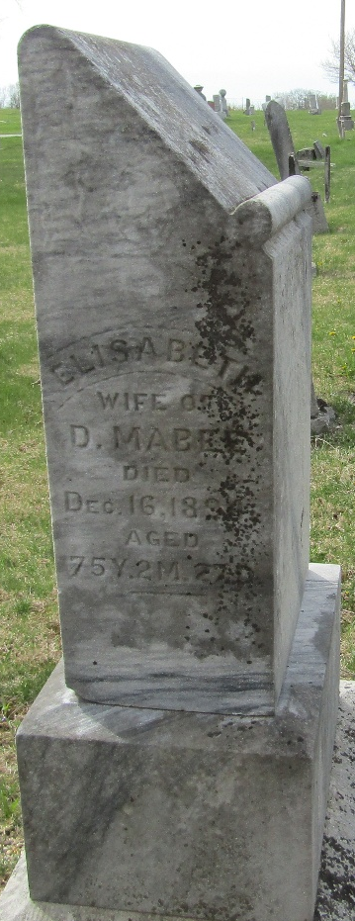

Elizabeth Lesh from tree Maybee Society
Birth 19 Sep 1819 Pennsylvania, USA
Marriage 1845
Residence 1880 Wells, Indiana, USA
Death 16 Dec 1894 Wells, Indiana, USA
Spouse David Maybee (1818-1864)

