David Mabee
December 8, 1818 – March 19, 1864

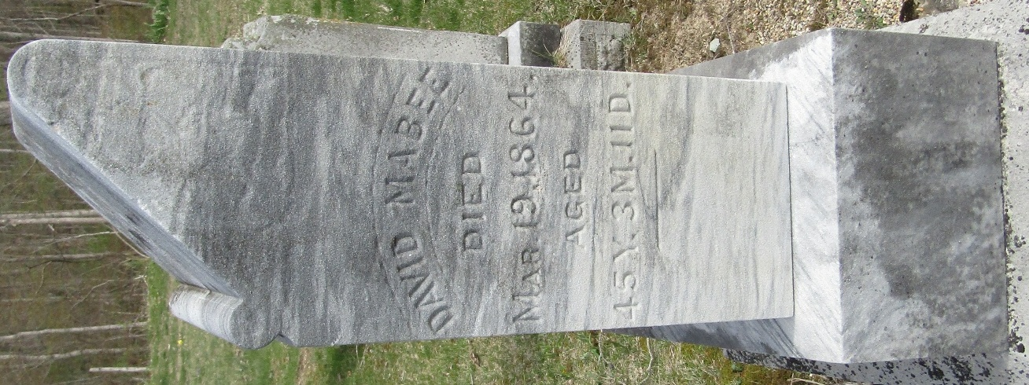

David Maybee from tree Maybee Society
Birth 8 Dec 1818 New Jersey, USA
Marriage 1845
Residence 1860 Wells, Indiana, USA
Death 19 Mar 1864 Wells, Indiana, USA
Father William Mabee (1778-1840)
Mother Letty May Barus (Born 1787)
Spouse Elizabeth Lesh (1819-1894)

