Oral Maxwell Lydy
July 31, 1914 – July 31, 1914

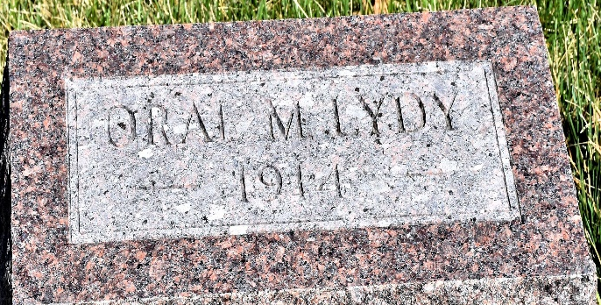

Oral Maxwell Leydy
in the Indiana, U.S., Death Certificates, 1899-2017
Name Oral Maxwell Lydy
Gender Male
Race White
Marital Status Single
Age 10 minutes
Birth Date 31 Jul 1914
Birth Place Wells County, Indiana
Death Date 31 Jul 1914
Death Place Lancaster, Wells, Indiana, USA
Death Registration Date 1910-1919
Father T. W. Lydy
Mother Devona Bush
Informant T. W. Lydy; Bluffton, Indiana
Burial July 31, 1914; Murray Cemetery

