Normal Basil Ward Lydy
July 9, 1885 – July 2, 1910

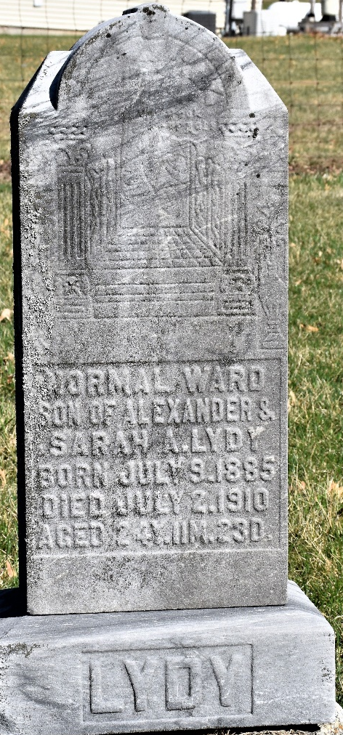

Basil Norman (sic) Ward Lydy, son of Alexander and Sarah Lydy, was born July the 9th, 1885, in Clinton County, Indiana, where he lived with his parents until nine years ago, when he came to Wells County to reside. He was married to Mary Burnett September 6, 1905. Two sons were born to this union, Austin R., aged four years, and Lester E., aged nineteen months.
He united with the Kingsland M. E. church two years ago under the ministry of the Rev. R. W. Stoakes. He has been in poor health for several months but not serious until Sunday, June the 26th, when he was taken very seriously sick. On the following Thursday he was taken to the Lutheran hospital in Ft. Wayne, and underwent an operation on Friday afternoon. He stood the operation well and seemed to give promise of a speedy recovery but on Saturday morning he began to sink very rapidly and in spite of kind hands and medical skill passed away about noon. He was twenty-four years, eleven months and twenty-three days old.
He leaves a wife, two sons, an aged father, three brothers, namely, T. W. Lydy, on the home place, A. A. Lydy of Lancaster township, and J. W. Lydy of Arizona, and one sister, Mrs. J. O. McCarty, south of Bluffton, besides a host of relatives and friends to mourn his untimely decease. His mother met a tragic death on the railroad in front of their home almost three years ago. One brother and four sisters have also gone before.
He was a good son, a loving husband, a kind father and true neighbor, ready to help any one he could. But the Master hath need of him and he is gone. A large concourse of relatives, neighbors and friends assembled at Emmaus M. E. church Tuesday morning, July the fifth, where the funeral services were conducted by the Rev. L. A. Sevits and the remains were interred in the Murray cemetery

Bluffton Chronicle, Wells County, Indiana
Wednesday, July 13, 1910
Page 8, column 2

**
Indiana, U.S., Death Certificates, 1899-2017

Name Normal Ward Lydy
Gender Male
Race White
Marital Status Married
Age 24
Birth Date 9 Jul 1885
Birth Place Indiana
Death Date 2 Jul 1910
Death Place Lafayette, Allen, Indiana, USA
Death Registration Date 1910
Father Alexander Lydy
Mother Sarah Hargrove
Spouse Mary
Informant Ted Lydy; Craigville, Indiana
Burial July 5, 1910; Murray Cemetery

