Devona D. (Bush) Lydy
November 26, 1886 – February 15, 1957
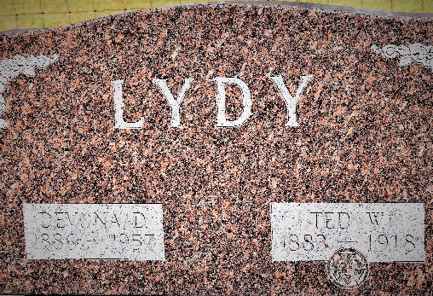

Devona D Lydy
in the Indiana, U.S., Death Certificates, 1899-2017
Name Devona D Lydy
[Devona D Bush]
Gender Female
Race White
Marital Status Widowed
Age 70
Birth Date 26 Nov 1886
Birth Place Indiana
Death Date 15 Feb 1957
Death Place Bluffton, Wells, Indiana, USA
Death Registration Date 1957
Father Isaiah Bush
Mother Alice Ann Maddux
Informant Max W. Lydy; son; Fort Wayne, Indiana
Burial February 17, 1957; Murray Cemetery; Murray, Indiana

