John Percy Nelson Luttrell
December 11, 1884 – June 19, 1909

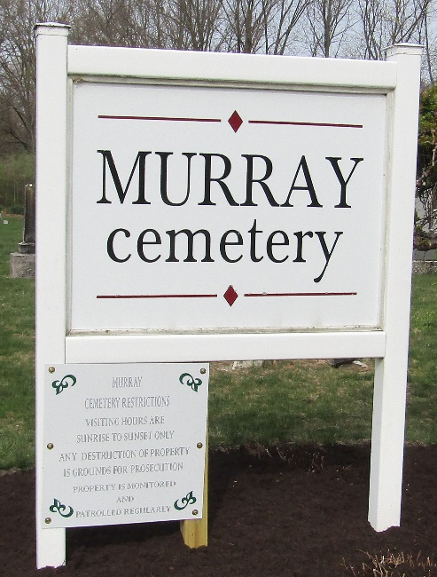
SUDDEN DEATH DUE TO EPILEPSY
John Lutrell Died Suddenly In Allen County – Funeral Today At Murray

John Lutrell, aged 24, a son of Mrs. David Somers, of Tocsin, died suddenly Saturday morning at the Geo. Neukam farm, five miles north of Fort Wayne, where he was employed as a farm laborer. His death was due to an epileptic fit, with which he was seized about five o’clock in the morning. He had been a victim of the fits frequently at one time, but this was the first he had suffered in a long time. He is survived by a wife and one small boy. The remains were brought back to this county for burial and funeral services were held at 2:30 o’clock this afternoon at Kingsland. Burial took place in the Murray cemetery.

Bluffton Chronicle, Wells County, Indiana
June 23, 1909

**
Indiana, U.S., Death Certificates, 1899-2017
Name John Luttrell
Gender Male
Race White
Marital Status Married
Age 24
Birth Date 11 Dec 1884
Birth Place Ohio
Death Date 19 Jun 1909
Death Place Fort Wayne, Allen, Indiana, USA
Death Registration Date 1909
Father John Luttrell
Mother Unknown
Spouse Mary
Informant Mary Luttrell
Burial June 22, 1909; Tocsin, Indiana
**
John Percy Nelson Luttrell from tree Karen Crowl Patterson
Birth 11 Dec 1883 Allen, Ohio, USA
Residence 1900 Wells, Indiana, USA
Marriage 16 Jan 1907 Wells, Indiana, USA
Death 19 Jun 1909 Allen, Indiana, USA
Father William N Luttrell (1854-1889)
Mother Jane Marette Isnogle (1860-1930)
Spouse Mary Glenn Powers (1885-1939)

