Otho Leo Lewis
February 2, 1915 – December 10, 1957

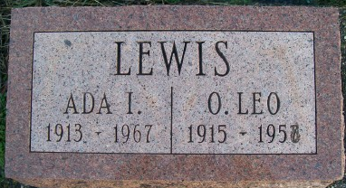

Otho Leo Lewis
in the Indiana, U.S., Death Certificates, 1899-2017
Name Otho Leo Lewis
Gender Male
Race White
Age 42
Birth Date 2 Feb 1915
Birth Place Indiana
Death Date 10 Dec 1957
Death Place Fort Wayne, Allen, Indiana, USA
Death Registration Date 1957
Father James J. Lewis
Mother Claudia Arnold
Informant Mrs. James Lewis; mother
Burial December 23, 1957; Murray Cemetery; Bluffton, Indiana

