Ada Irene (Cox) Lewis
March 14, 1913 – July 5, 1967

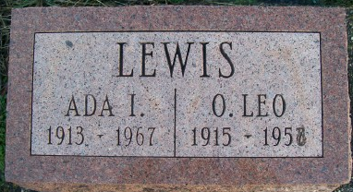

Ada Irene Lewis
in the Indiana, U.S., Death Certificates, 1899-2017
Name Ada Irene Lewis
[Ada Irene Cox]
Gender Female
Race White
Marital Status Widowed
Age 54
Birth Date 14 Mar 1913
Birth Place Texas
Death Date 5 Jul 1967
Death Place Huntington, Huntington, Indiana, USA
Death Registration Date 1967
Father S E Cox
Mother Dollie Phillips
Informant Mrs. Martha Brown; friend; Huntington, Indiana
Burial July 8, 1967; Murray Cemetery; Murray, Indiana

