Tamer E. Leeper
January 23, 1851 – January 26, 1872

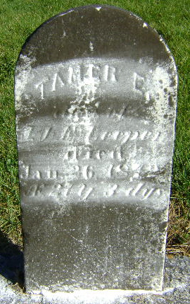
Photo by Bruce Sonner

Tamer E. Leeper from tree Dawson Family Tree

Birth 23 Jan 1851 Wells, Indiana, USA
Residence 1860 Indiana, USA
Death 26 Jan 1872 Wells, Indiana, USA
Father Jacob Leeper (1815-1870)
Mother Elizabeth Nelson (1814-1910)
17039 People 2 Records 3 Sources

