Orlando H. Leeper
1842 – February 28, 1864

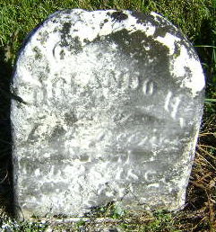
Orlando Leeper
in the U.S., Civil War Soldiers, 1861-1865
Name Orlando Leeper
Side Union
Regiment State/Origin Indiana
Regiment 101st Regiment, Indiana Infantry
Company G
Rank In Private
Rank Out Private
Alternate Name Leander/Leper
Film Number M540 roll 43

**
Orlando H. Leeper from tree Blanton Family Tree
Birth 1842 Ohio, USA
Residence 1860 Bartholomew, Indiana, USA
Death 28 Feb 1864
Father Jacob Leeper (1815-1870)
Mother Elizabeth Nelson (1814-1910)

