Jacob L. Leeper
1854 – March 12, 1855

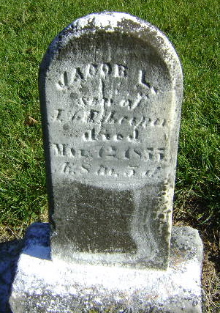

Jacob L. Leeper from tree The Hardesty Tale
Birth Jun 1854 Wells, Indiana, USA
Death 12 Mar 1855 Wells, Indiana, USA
Father Jacob Leeper (1815-1870)
Mother Elizabeth Nelson (1814-1910)

