Jacob Leeper
October 26, 1815 – May 7, 1870

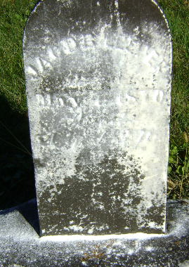

Jacob Leeper from tree Dawson Family Tree
Birth 26 Oct 1815 Pennsylvania, USA
Marriage 8 Nov 1838 Stark, Ohio, USA
Residence 1860 Indiana, USA
Death 7 May 1870 Wells, Indiana, USA
Father F Leeper
Spouse Elizabeth Nelson (1814-1910)

