Rachel Rebecca (Borden) Ledbetter
August 3, 1815 – October 19, 1893

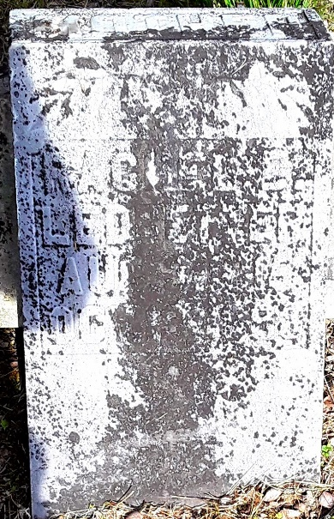

Rachel Rebecca Borden from tree The COMPLETE Family Tree

Birth 3 Aug 1815 Burlington, Burlington, New Jersey, USA
Marriage 5 Oct 1839 Greene, Trumbull, Ohio, USA
Residence 1880 Wells, Indiana, USA
Death 19 Oct 1893
Father Joshua Borden (1790-1851)
Mother Mary Steele (1793-1820)
Spouse James Duglas Ledbetter (Born 1812)

