James Duglas Ledbetter
August 29, 1812 – December 27, 1891

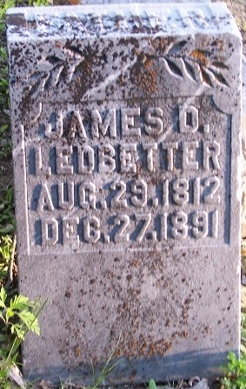

James Duglas Ledbetter from tree Gary Stephens family tree
Birth 29 Aug 1812 Virginia, USA
Marriage 3 Oct 1839 Greene, Trumbull, Ohio, USA
Residence 1880 Wells, Indiana, USA
Death 27 Dec 1891 Wells, Indiana, USA
Father Hamlin Ledbetter (1775-1836)
Mother Dicey Ann Wright (1785-1840)
Spouse Rachel Rebecca Borden (1815-1893)

