Luddie (Webber) Lawrence
February 27, 1851 – September 20, 1909

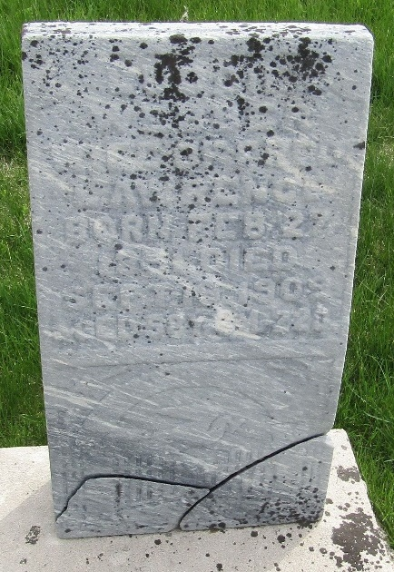

Luddie Lawernce
in the Indiana, U.S., Death Certificates, 1899-2017
Name Luddie Lawrence
[Luddie Webber]
Gender Female
Race White
Marital Status Married
Age 58
Birth Date 27 Feb 1851
Birth Place Wayne County, Ohio
Death Date 20 Sep 1909
Death Place Harrison, Wells, Indiana, USA
Death Registration Date 1909
Father Adam Webber
Mother Catherin Cramer
Informant Fred Lawrence; Bluffton, Indiana
Burial September 22, 1909; Murray Cemetery

