Sarah Elizabeth (Kleinknight) Lash
January 27, 1858 – May 28, 1927

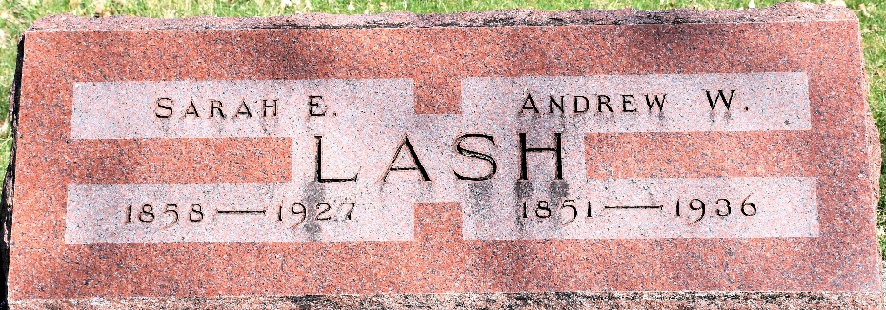
Photo by Colleen Sanders Broyles
Sarah Elizabeth Lash
in the Indiana, U.S., Death Certificates, 1899-2017
Name Sarah Elizabeth Lash
[Sarah Elizabeth Kleinknight]
Gender Female
Race White
Marital Status Married
Age 64
Birth Date 27 Jan 1858
Birth Place Crawford County, Ohio
Death Date 28 May 1927
Death Place Lancaster, Wells, Indiana, USA
Death Registration Date 1926-1927
Father Jacob Kleinknight
Mother Elizabeth Miller
Spouse Andrew Lash
Informant Andrew Lash; Craigville, Indiana
Burial May 31, 1927; Murray Cemetery

