Lydia J. Lash
1853 – May 6, 1864

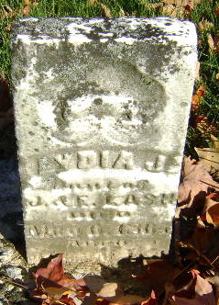
Photo by Bruce Sonner

Lydia Lash from tree Wild Bill & The Indian
Birth 1853 Indiana, USA
Death 1864 Wells, Indiana, USA
Father Jacob Lash (1832-1900)
Mother Elizabeth Baker (1831-1921

