Kabbry Lash
1856 – February 11, 1857

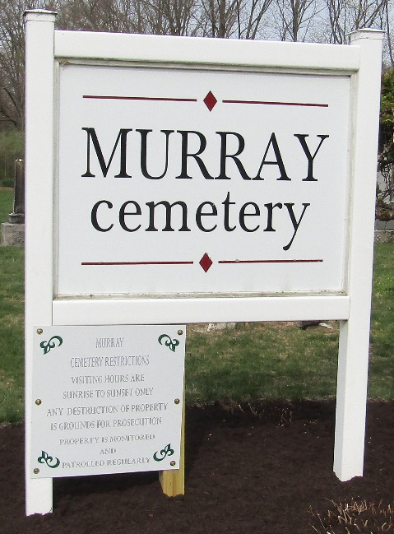
Photo by Colleen Sanders Broyles

Kabbry Lash from tree Randy Gamble
Birth 1856 Wells, Indiana, USA
Death 11 Feb 1857 Wells, Indiana, USA
Father Isaac Lash (1802-1876)
Mother Matilda Fisher (1818-1877)
88884 People 1 Record 4 Sources

