Ella (Ledbetter) Lash
June 2, 1857 – September 14, 1902

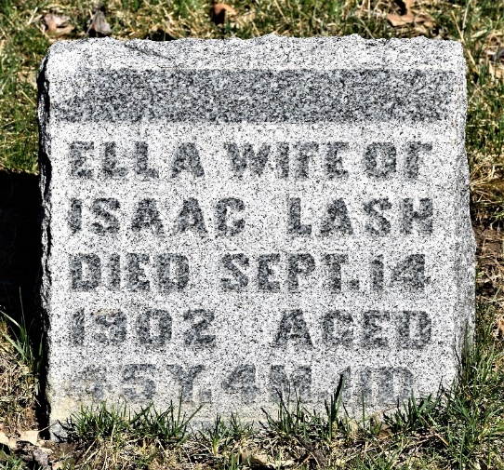
Photo by Colleen Sanders Broyles
Died of Consumption

Mrs. Isaac Lash died at her home three miles and a half north of the city yesterday morning at two o’clock, after two years of suffering with consumption.
The funeral was held at the residence at ten o’clock this morning with Rev. C. S. Lester in charge. The remains were interred in the cemetery at Murray.

Bluffton Evening News, Indiana,
Monday, September 15, 1902

**
Indiana, U.S., Death Certificates, 1899-2017
Name Ella Lash
[Ella Ledbetter]
Gender Female
Race White
Marital Status Married
Age 45
Birth Date 2 Jun 1857
Birth Place Wells County, Indiana
Death Date 14 Sep 1902
Death Place Lancaster, Wells, Indiana, USA
Death Registration Date 1902
Father James Ledbetter
Mother Catherine Boder
Spouse Isaac Lash
Informant Isaac Lash; Bluffton, Indiana
Burial September 15, 1902; Murray Cemetery

