David Lash
1808 – March 9, 1876

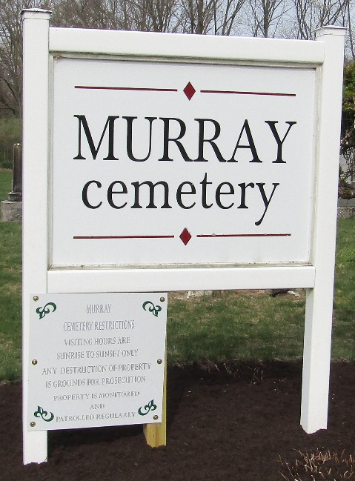
Photo by Colleen Sanders Broyles

David Lash from tree Tulk Family Tree
Birth 1808
Death 9 Mar 1876
Father Isaac Lash
Mother Eva Swickard (Born 1771)
Spouse Susanna (1827-1880)

