Daisy Lell Lash
December 17, 1878 – February 8, 1904

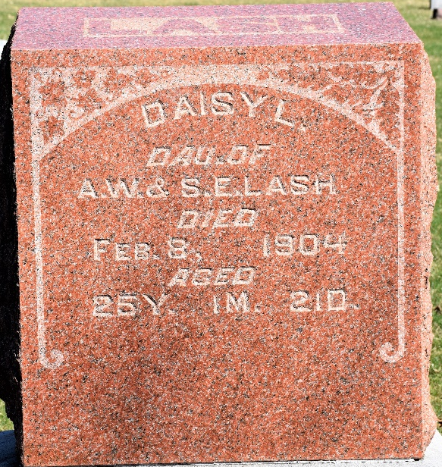
Photo by Colleen Sanders Broyles

Daisy, daughter of Andrew W. Lesh, died Tuesday at her home north west of Bluffton after a sickness of several weeks. She was aged twenty-five years. The funeral services was held Thursday forenoon at 10 o’clock from the residence with interment at Murray.

Unknown newspaper clipping

**
Indiana, U.S., Death Certificates, 1899-2017
Name Daisy Lell Lash
Gender Female
Race White
Marital Status Single
Age 25
Birth Date 17 Dec 1878
Birth Place Wells County, Indiana
Death Date 8 Feb 1904
Death Place Near Tocsin, Wells, Indiana, USA
Death Registration Date 1904
Father Andrew W Lash
Mother Sarah E. Klinite
Informant Sarah Klinite; Tocsin, Indiana
Burial February 11, 1904; Murray Cemetery

