Andrew William Lash
January 20, 1851 – February 4, 1936

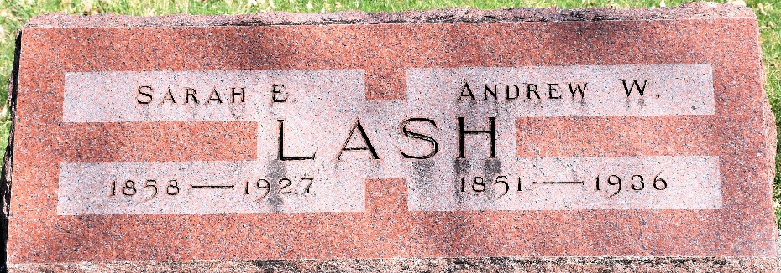
Photo by Colleen Sanders
DEATH OF WELLS COUNTY MAN CAUSED BY EXPOSURE

Bluffton, Ind., Feb. 5 - Andrew W. Lash, 85, near Tocsin, Wells County, died last night at the home of a daughter, Mrs. Arnold Simon, of Berne, and his death was attributed to complications that developed due to exposure during the blizzard two weeks ago. He had been living alone on a farm three miles southwest of Tocsin. The night the blizzard was at its height, he was found in the yard in his home by Lloyd Wolcott, a neighbor who had become worried about him, and went to investigate. He had gone to an outbuilding to feed chickens and had fallen and injured a crippled leg and was unable to find his way to the house. Examination revealed that his hands and feet had been frozen. He was taken to the home of his daughter for care and treatment, and at first appeared to improve, but suffered a relapse.
He was preceded in death by his wife.
Surviving is a son, Samuel Lash of Markle, and three daughters, Mrs. Simon, Mrs. James High of Bluffton, and Mrs. Alfred Earhart of Gallion, O.
Funeral services will be held at 1:30 o’clock on Friday afternoon at the home of the daughter at Berne, and burial will be in the Murray Cemetery, four miles northwest of Bluffton.

The Star Press, Muncie, Indiana
Thursday, February 6, 1936

**
Indiana, U.S., Death Certificates, 1899-2017
Name Andrew William Lash
Gender Male
Race White
Marital Status Widower
Age 85
Birth Date 20 Jan 1851
Birth Place Indiana
Death Date 4 Feb 1936
Death Place Berne, Adams, Indiana, USA
Death Registration Date 1936
Father Isaac Lash
Mother Sarah Kleinkight
Informant Mrs. Effie Earhart; Gallion, Ohio
Burial February 7, 1936; Murray Cemetery

